**Probability for Data Science**

**What is Probability?**

* Probability is a measure of how likely an event is to occur.
* It is expressed as a number between 0 and 1, where 0 indicates that the event will not happen, and 1 indicates that the event will certainly happen.
* The closer the probability is to 1, the more likely the event is, and the closer it is to 0, the less likely it is.

**Here's a breakdown:**

0: Impossible event (it will not happen).

0.5: Event is equally likely to happen or not happen (50-50 chance).

1: Certain event (it will definitely happen).

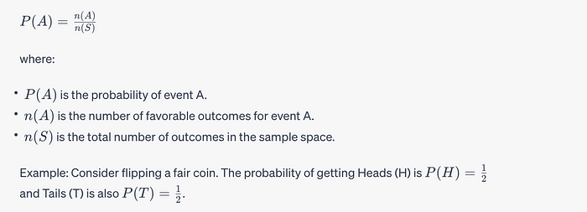

## Terminologies

* **Experiment**: Action or set of actions performed. Ex. Flipping a coin.
* **Outcome**: A single possibility from the experiment. Ex. Getting head or tail after a coin is flipped.
* **Sample Space:** The set of all possible outcome. Ex. Head and Tail are two possible outcome of flipping a coin.
* **Event**: Something we can observe. An outcome or occurrence that has a probability assigned to it. Ex. Getting exactly 2 heads when 2 coins are flipped.

# **Event Types**

## Mutually Exclusive

If two events are **mutually exclusive**, only **one of the two can occur** or the **occurrence of one excludes the occurrence of other.**

## Example

**Probability of a random card drawn being a King or a Queen.**

A card can be either a King or a Queen but not both. Picking a King excludes the chances of it being a Queen, vice versa.

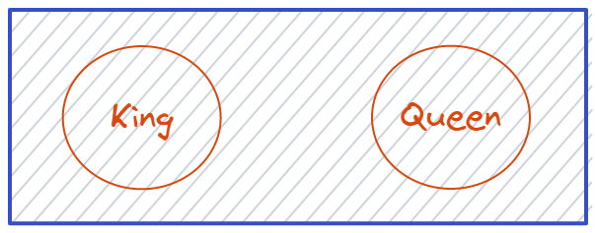

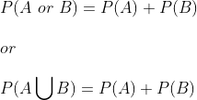

## Not Mutually Exclusive

If two events are **not mutually exclusive**, both can occur or the **occurrence of one doesn’t excludes the occurrence of other.**

## Example

**Probability of a random card drawn being a King or a Diamond.**

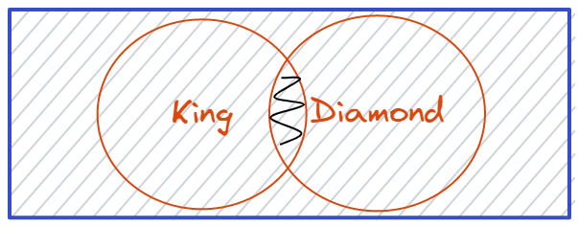

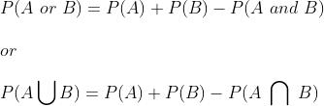

**Note:**

*If events****A and B****are****exclusive****, then***P(A∩B) = 0**

*If events****A and B****are****exhaustive****, then***P(A∪B)= 1***.*

## Independent

If two events **intersect**, or are **independent**, it’s possible they can occur simultaneously.

## Example

**Probability of a random card drawn being a King or a Diamond.**

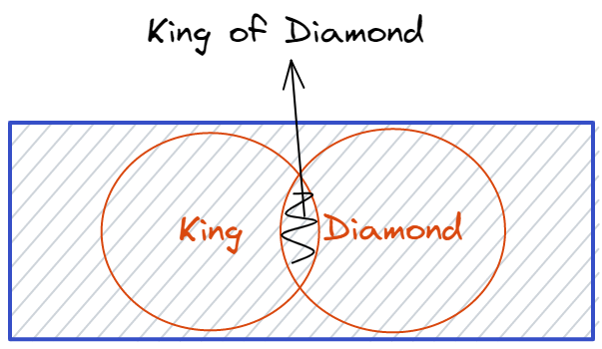

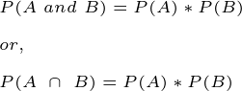

## Dependent

If two events **dependent**, the occurrence of one event affect theprobability of occurrence of the other.

## Example

Drawing two different color balls from a bag of balls.

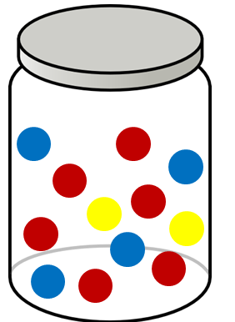

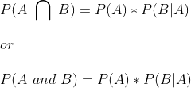

AND

https://miro.medium.com/v2/resize:fit:280/0*rkw9sQ2YRJAexTKj

## Conditional Probability:

Conditional probability calculates the likelihood of an event occurring given that another event has already occurred.

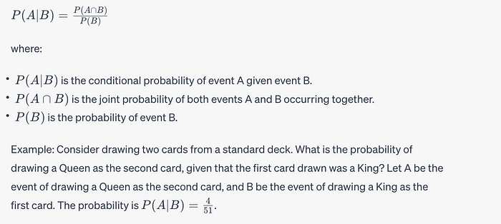

# **Law of Total Probability**

If we have two events A and B, then,

https://miro.medium.com/v2/resize:fit:618/0*1MBaRqTmkW_56cmT

The Law of Total Probability is the denominator of Bayes’ Theorem.

# **Bayes’ Theorem**

Describes how the conditional probability of each of a set of possible causes for a given observed outcome can be computed from knowledge of the probability of each cause and the conditional probability of the outcome of each cause.

https://miro.medium.com/v2/resize:fit:410/0*z6cyHAN5e_WAfmci

Bayes’ Theorem

Therefore,

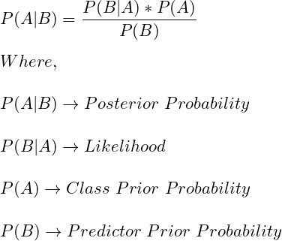

## Expectation and Variance:

Expectation (mean) and variance are statistical measures that provide valuable insights about a random variable.

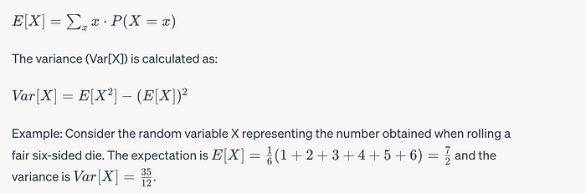

## Joint Probability and Marginal Probability:

Joint probability deals with the probability of two or more events occurring together. On the other hand, marginal probability involves the probability of a single event regardless of the occurrence of other events.

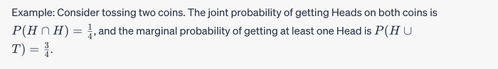

# Random Variables

**Discrete Random Variables**

* Probability Mass Function (PMF)
* Likelihood Functions
* Maximum Likelihood Estimate
* Bernoulli distribution
* Geometric Distribution
* Binomial Distribution
* Poisson distribution

**Continuous Random Variables**

* Cumulative Distribution Function (CDF)
* Probability Distribution Function (PDF)
* Kernel Density Estimate (KDE)
* Likelihood Functions
* Uniform Distribution
* Exponential Distribution
* Gaussian distribution